**­­­**

**Programming**

**&**

**Algorithm**

**Class 7**

**Lab Class 1**

**Basic Programming**

**Lab Objectives:**

* What is Programming?
* Overview of Programming Languages.
* Variables in Programming Languages.

**What is Programming?**

Computer programming is a way of giving computers instructions about what they should do next. These instructions are known as code, and computer programmers write code to solve problems or perform a task.

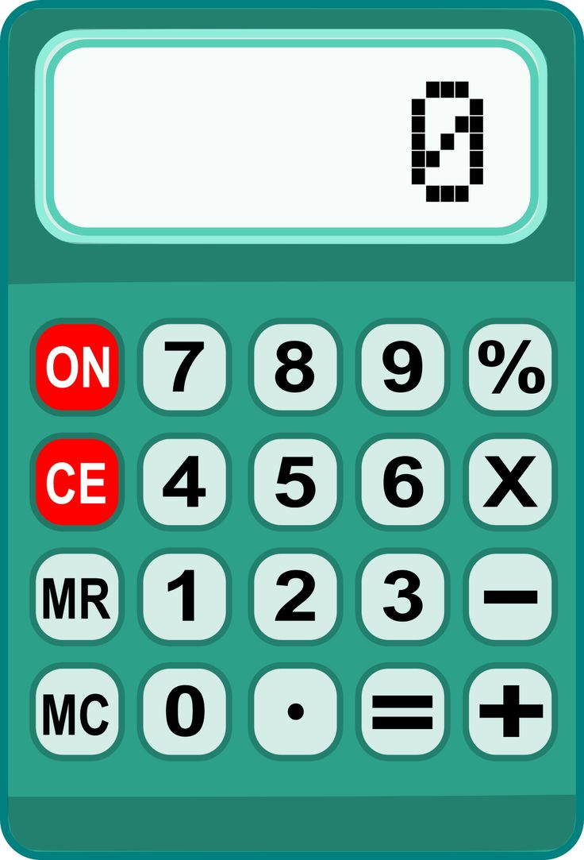The goal of programming is creating an executable program to solve problem using machine or computing devices.

Example: A calculator which is programmed in such a way so that it we can add, divide, multiply numbers.

**What is Programming Languages?**

A programming language is a vocabulary and set of grammatical rules for giving commands and instruction to a computer or computing device to perform specific tasks.

Each programming language has a unique set of keywords (words that it understands) and a special syntax for organizing program instructions.

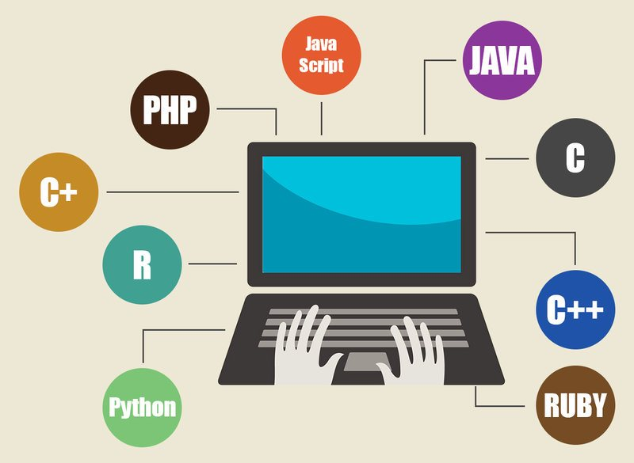

Figure : Some Programming Languages’ Name

**What can we do using Programming languages?**

* Websites: YouTube, Google, Amazon etc.

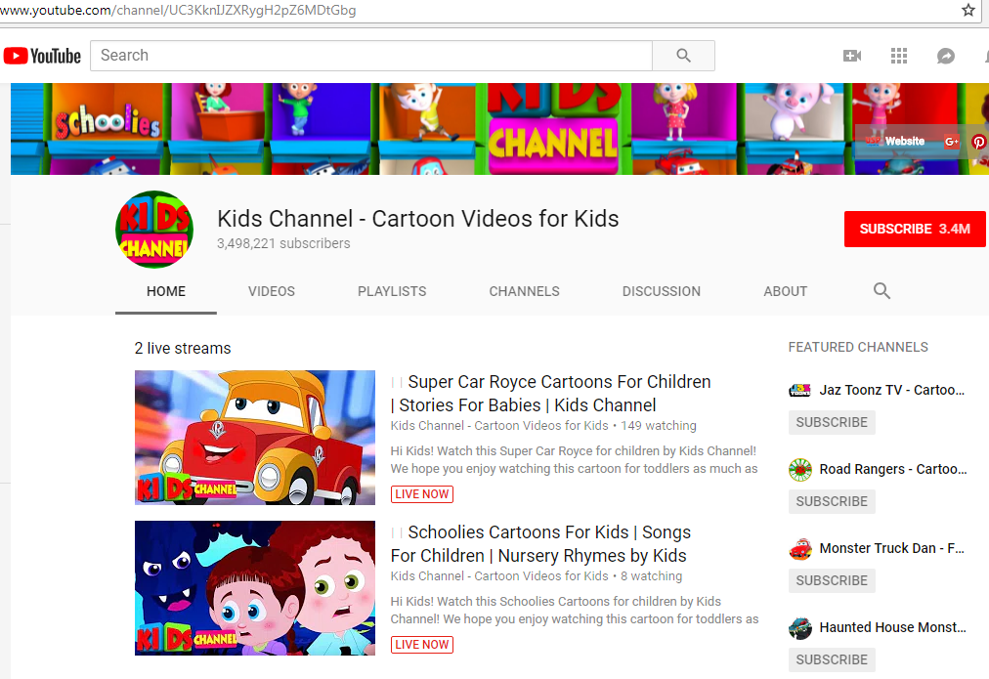

* Mobile & Desktop Applications: Messenger, WhatsApp, Playstore etc.



**Variables**

Variables are containers for storing data values.

var x = 5;  
var y = 6;  
 var z = x + y;

In this example, x, y, and z, are variables. From the example above, we can expect:

* x stores the value 5
* y stores the value 6
* z stores the value 11

**5**

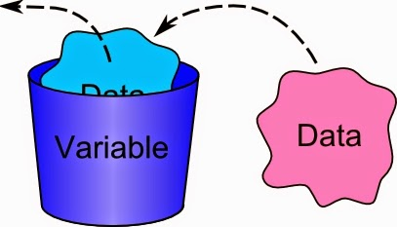

**5**

**X**

Exercise:

var price1 = 300;  
var price2 = 430;  
var total = price1 + price2;

**So, what is the value of total?**

**Variables: Data Type**

Most common and basic data type in programming languages are:



Integer

var marks = 80;



var grade = 4.50;

Decimal



var name = “Zyan”

String